[](http://web.archive.org/web/)

|  |  |  |  |  |  |  |  |  |  |  |  |
| --- | --- | --- | --- | --- | --- | --- | --- | --- | --- | --- | --- |
| Top of Form    Bottom of Form | | |  |  |  | | --- | --- | --- | | [**FEB**](http://web.archive.org/web/20060213014950/http:/www.homeracingworld.com:80/ArtinBrakes.htm) | **MAR** | [**JUL**](http://web.archive.org/web/20060708105234/http:/www.homeracingworld.com:80/ArtinBrakes.htm) | | **[Previous capture](http://web.archive.org/web/20060213014950/http:/www.homeracingworld.com:80/ArtinBrakes.htm)** | **28** | **[Next capture](http://web.archive.org/web/20060708105234/http:/www.homeracingworld.com:80/ArtinBrakes.htm)** | | [**2004**](http://web.archive.org/web/20041206052016/http:/www.homeracingworld.com:80/ArtinBrakes.htm) | **2006** | [**2007**](http://web.archive.org/web/20070416102827/http:/www.homeracingworld.com:80/ArtinBrakes.htm) | |
| [**33 captures**](http://web.archive.org/web/*/http:/www.homeracingworld.com/ArtinBrakes.htm)  7 Dec 2002 - 24 Mar 2021 |  |

[About this capture](http://web.archive.org/web/20060328030959/http:/www.homeracingworld.com/ArtinBrakes.htm#expand)

[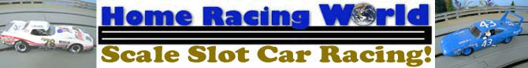](http://web.archive.org/web/20060328030959/http:/www.homeracingworld.com/index.htm)

***Puttin' On The Brakes...!***

**Wiring Your Artin Track For Brakes**

December 1st, 2002

This is a small article to help you in the event you want brakes installed on your Artin Track. If you have not done so already, go out and get yourself a pair (or 4 if your doing a 4 lane) PARMA Economy controllers (25 or 45 ohm). You can [READ HERE](http://web.archive.org/web/20060328030959/http:/www.homeracingworld.com/upgrading_artin.htm) how to wire these to your current Artin Power Base, before you attempt this upgrade.

However, you need to make one small change to get brakes working on your layout. In that article it mentions the red wire on the PARMA controllers. Well, this is your BRAKE wire. And this time, instead of just folding it back and away, we are going to use it.

Take this RED wire from your PARMA controllers, and attach (Soldering Preferred) a longer wire to it. It is going to be ran UNDERNEATH your track and attached to the "black" side of the lane specific for this controller. Any good grade of wire will work, but one of the least expensive way to get wire is to buy household extension cords. It is heavy enough to use for most anything in our hobby.

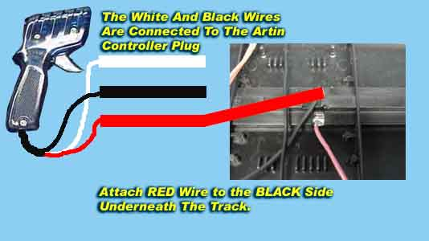

By following the above diagram, you will have brakes quickly and easily. Solder this wire to black side of the 2 rails shown. Now repeat this step on each controller. This is lane specific, so for each controller, the red wire must be attached for that particular lane the controller is assigned.

And that's it, pretty simple isn't it? The Artin Power and Control System can be easily upgraded, along with being quite inexpensive. All it takes is a few upgrades to make your track ready for club or organized racing.

As always, feel free to email me at [wiseone@yhti.net](http://web.archive.org/web/20060328030959/mailto:wiseone@yhti.net) about this upgrade or just the hobby in general.

***Harry***

